**Description:**

The below mentioned Observations include all the types like Suggestions, Corrections/Bugs, Feedback. Application looks Automation compatible but some field makes it difficult to perform by complex UI objects.

**Observations:**

1. **If Upload buttons are given for Photo and Signature here, it would look good.**

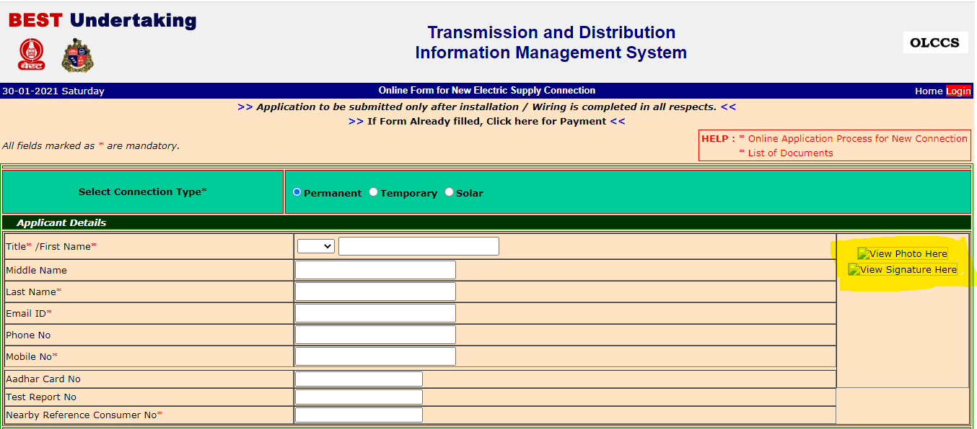

1. **In Power supply Address, if there is a drop downs for Type of Premise, Category of Premise, Preferred language that will look good, as there are many options present it is good to have a dropdown instead.**

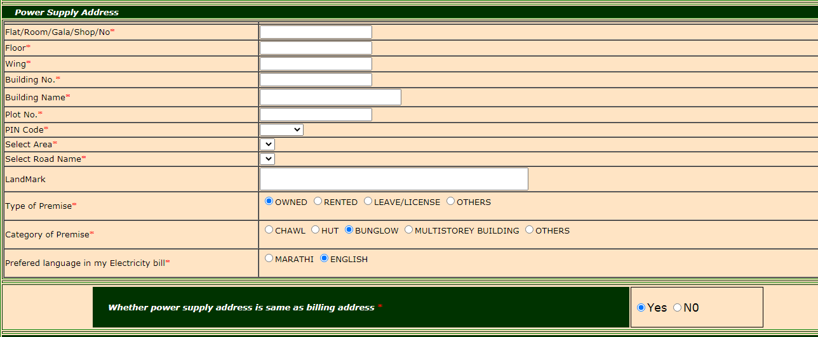

1. **Pin code field should be a text field where user can enter the value instead of selecting from a drop down**

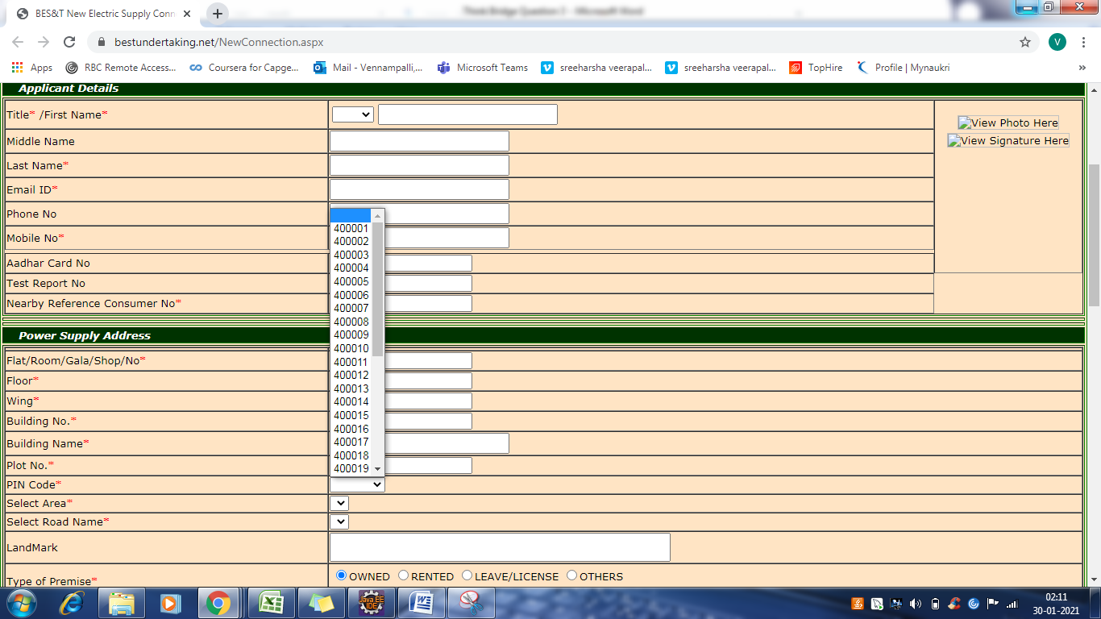

1. **Instead on clicking upload after choosing documents, we can remove the upload buttons and process the functionality in Choose file itself**

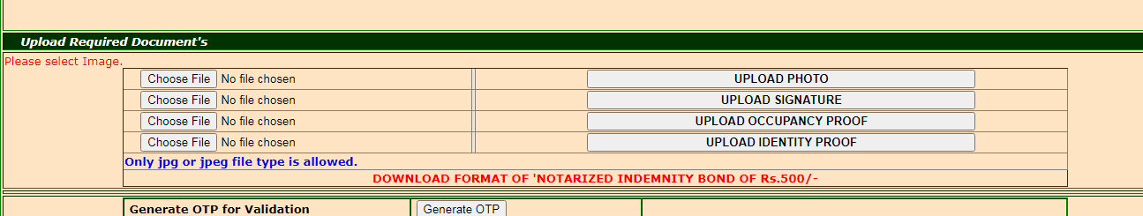

1. **Better to have uploaded file name instead of No File chosen for clear understanding**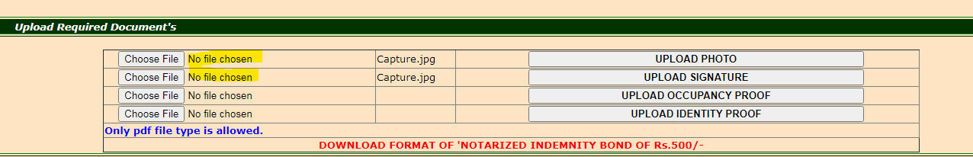
2. **When User try to Enter Alphanumeric values for Negative testing in Connection Details section, it is getting navigated to some other Error page and unable to Navigate to original page using back button.**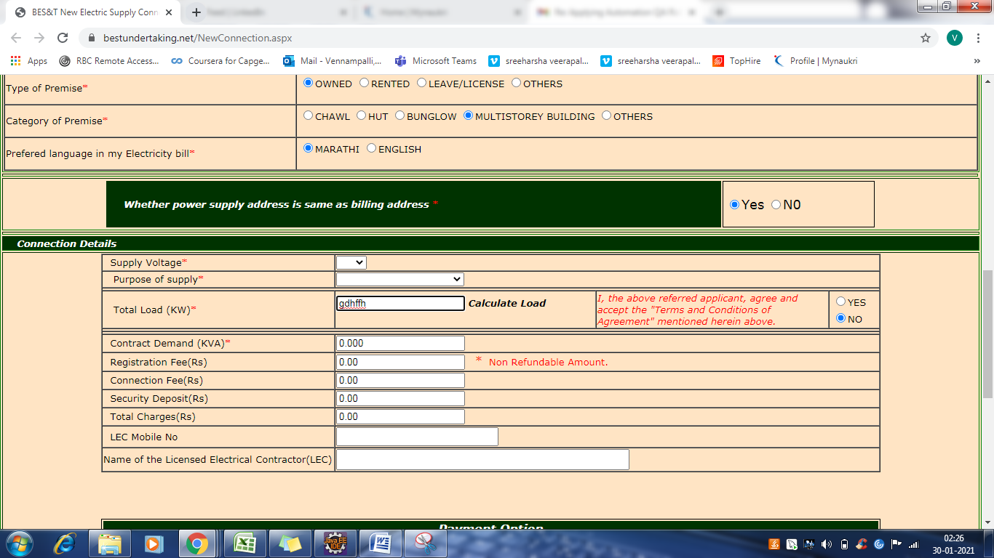

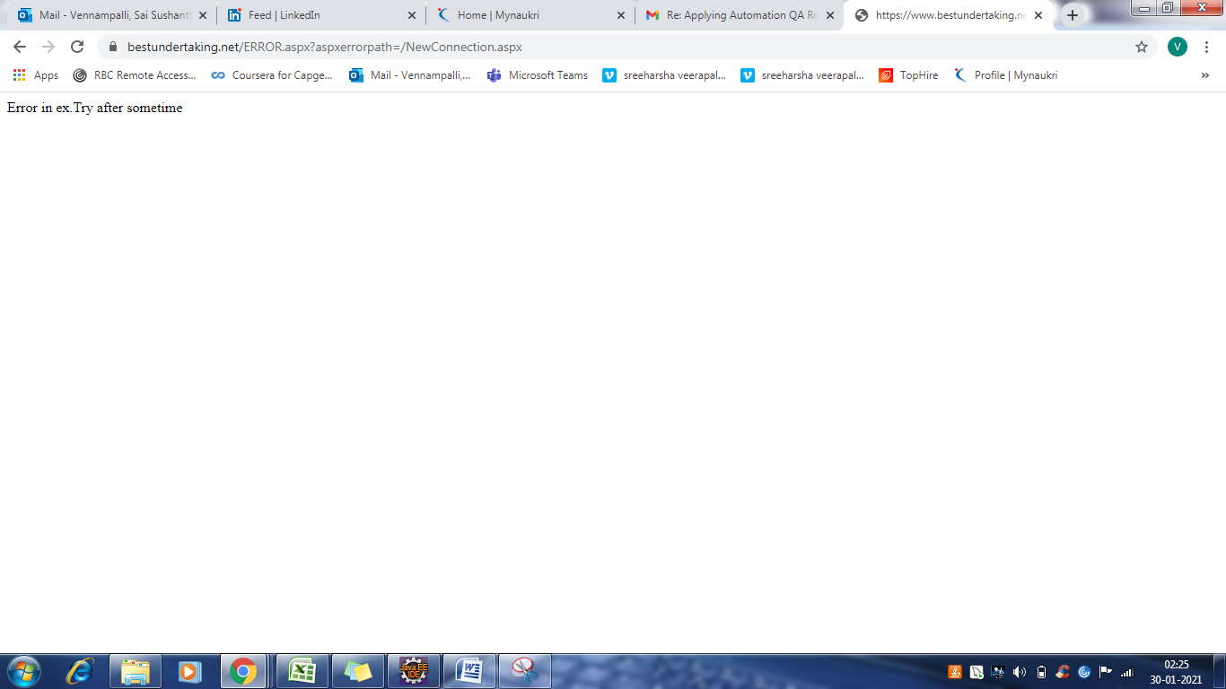

1. **It would be more easier for the end user, if there is a Save and Next, Reset or Clear buttons present for each section on the entered values**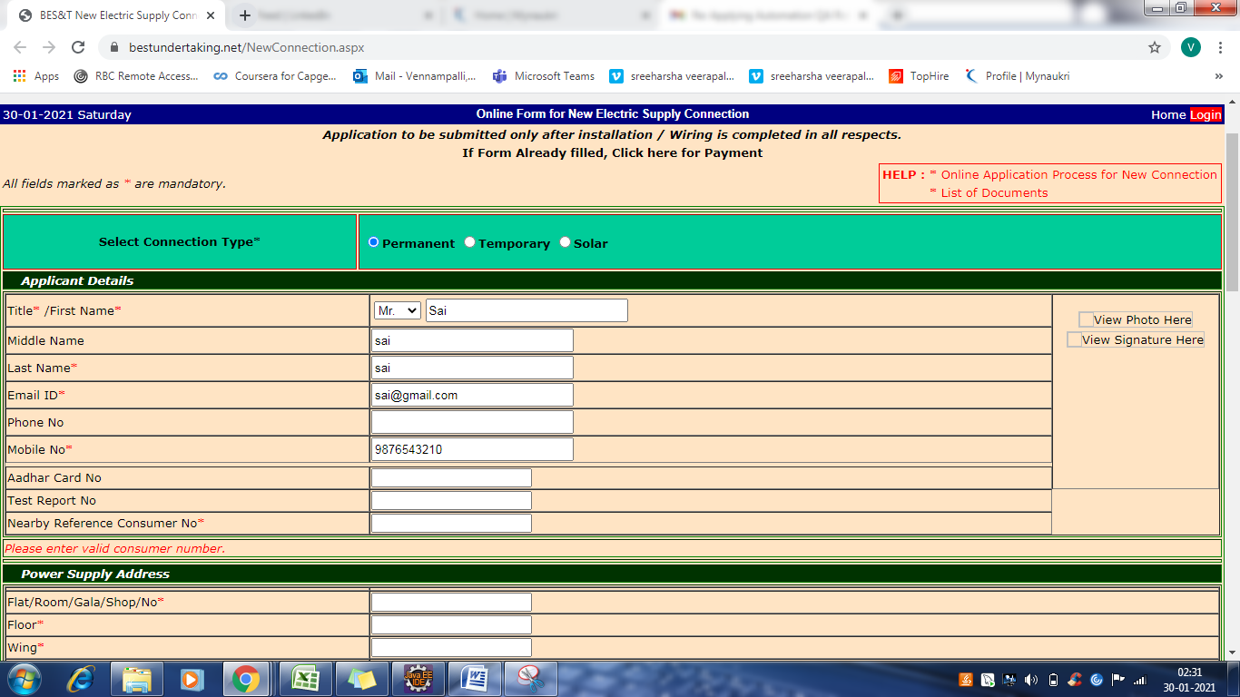
2. **It would be more better, if the fields like Floor, Wing, Building No and Name, Plot Number are given as Optional or set up some error message for some specified conditions, or user can Enter any Symbols also(As part of Negative testing)** 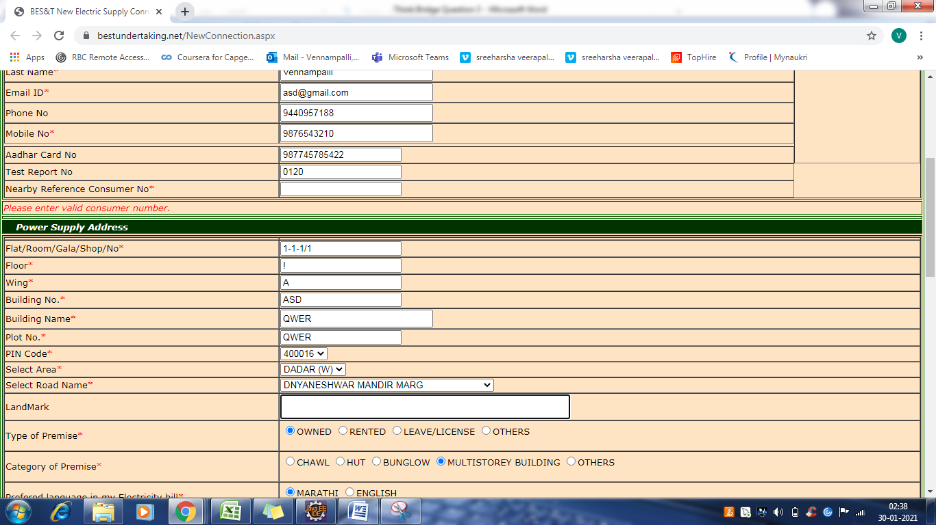
3. **If I click on Reset button, all the fields are not set to blank**

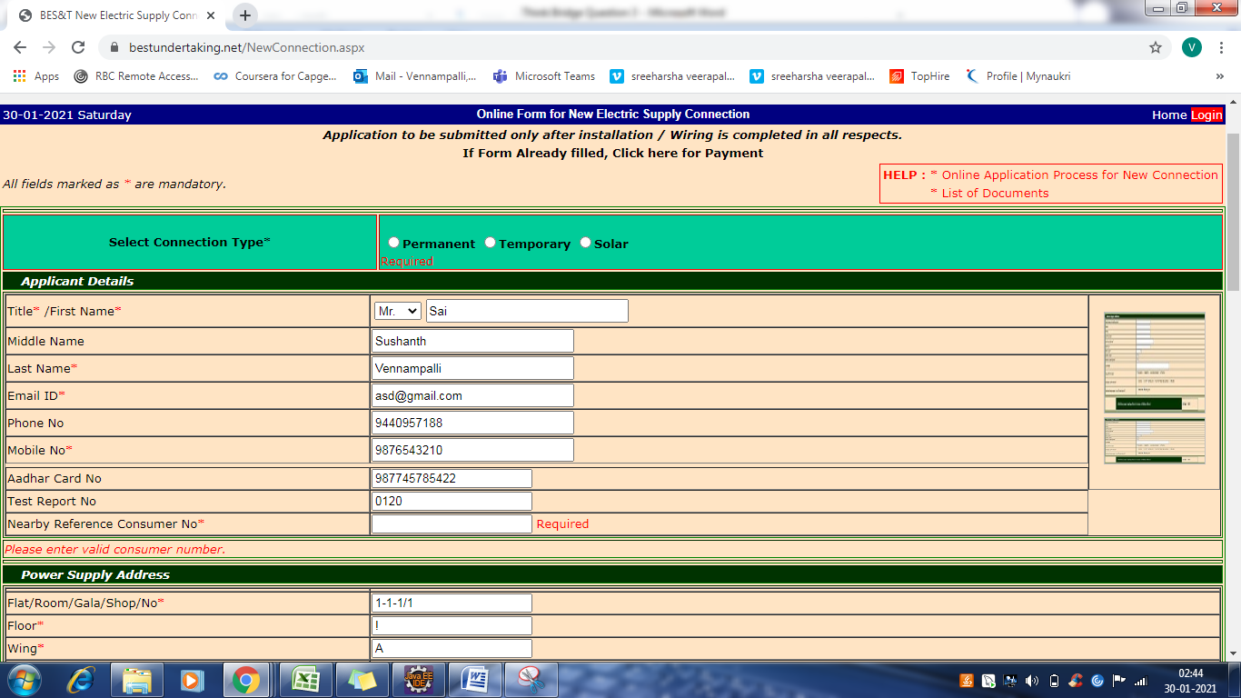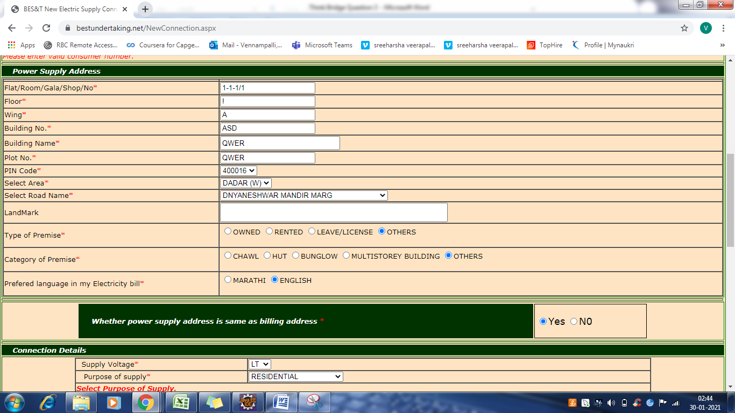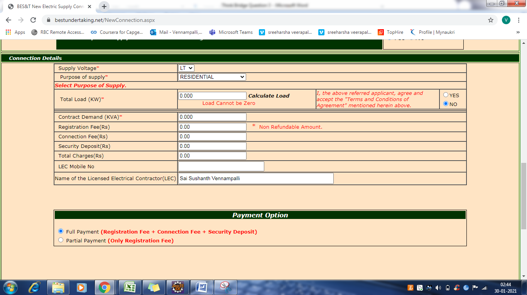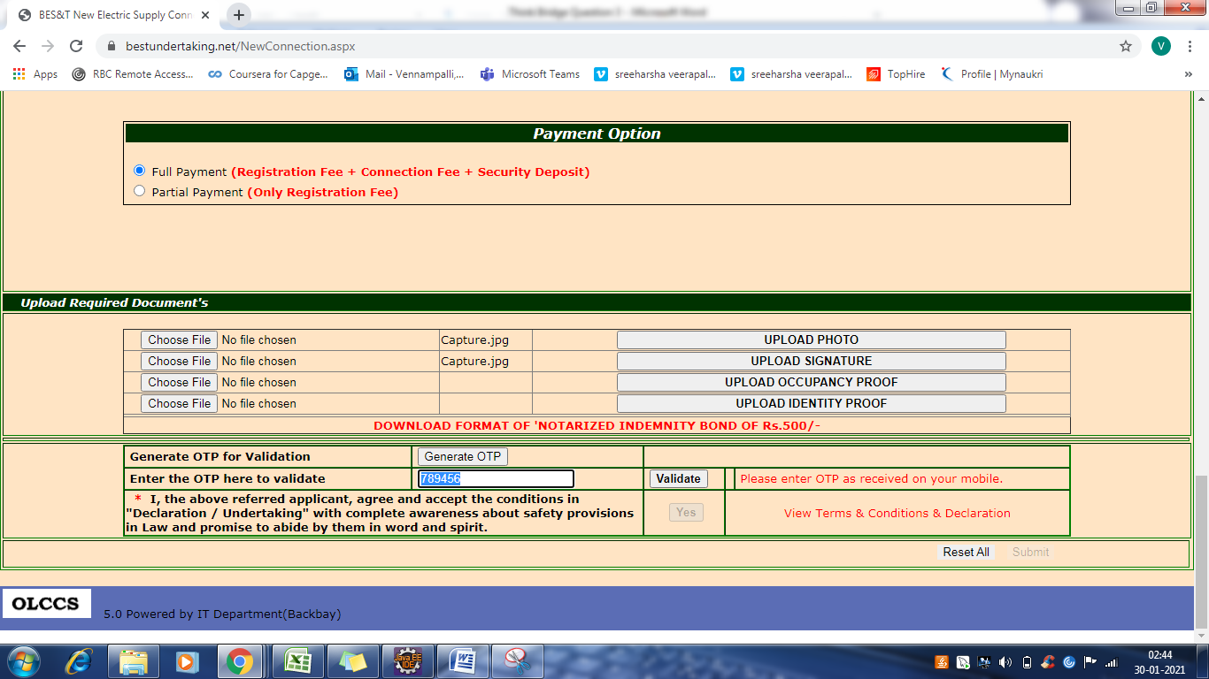

**After clicking on reset all not all the fields are set to blank**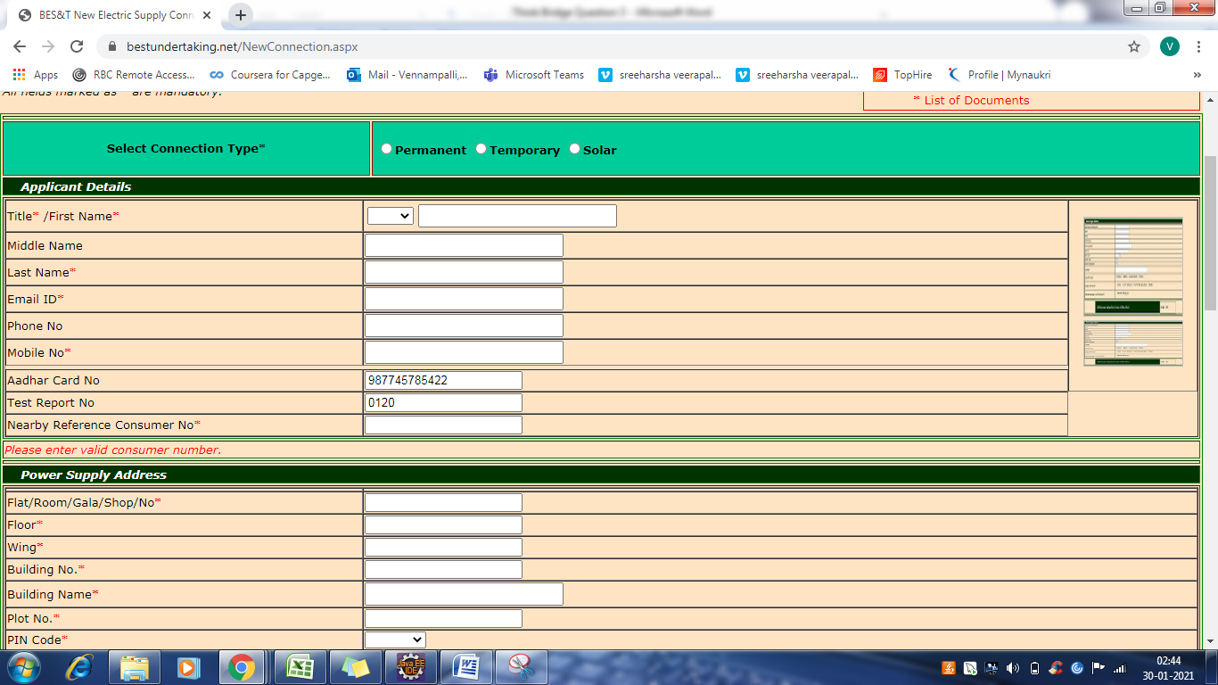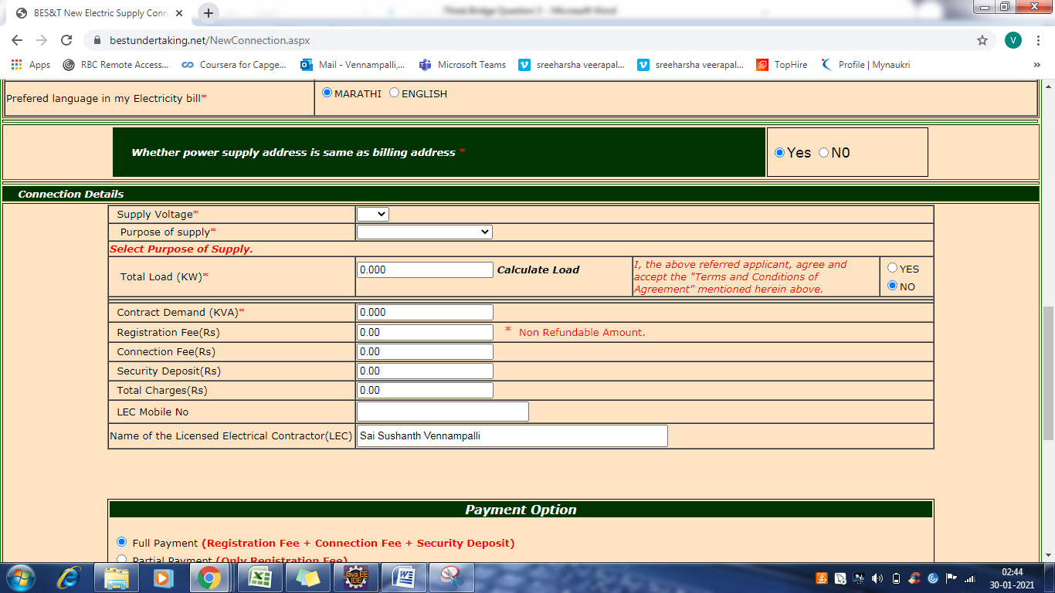

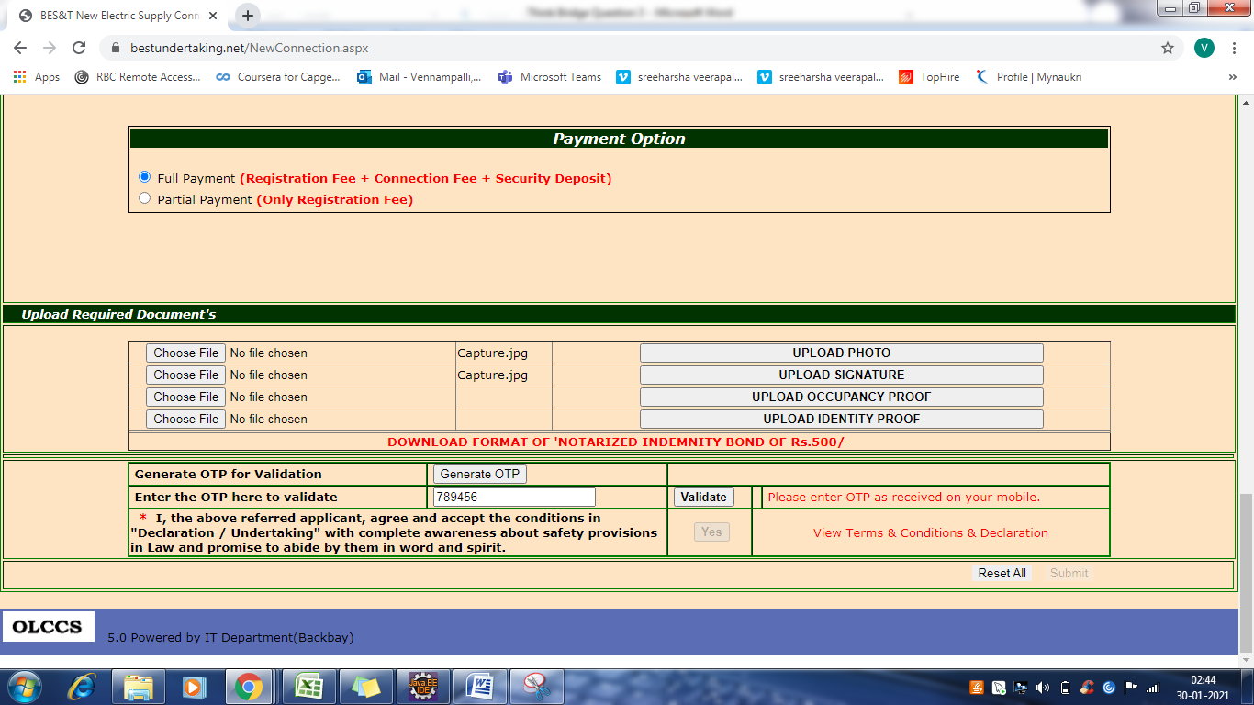

1. **If there is a dropdown to handle fields based on connection selection that looks good**

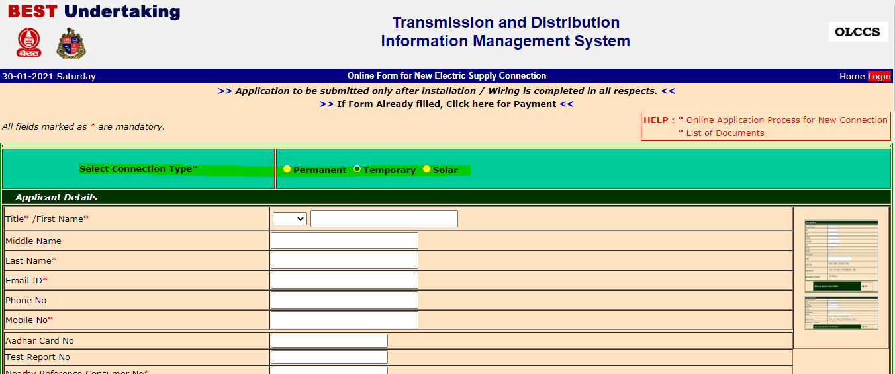

1. **Title of the webpage might not be Exactly centered**

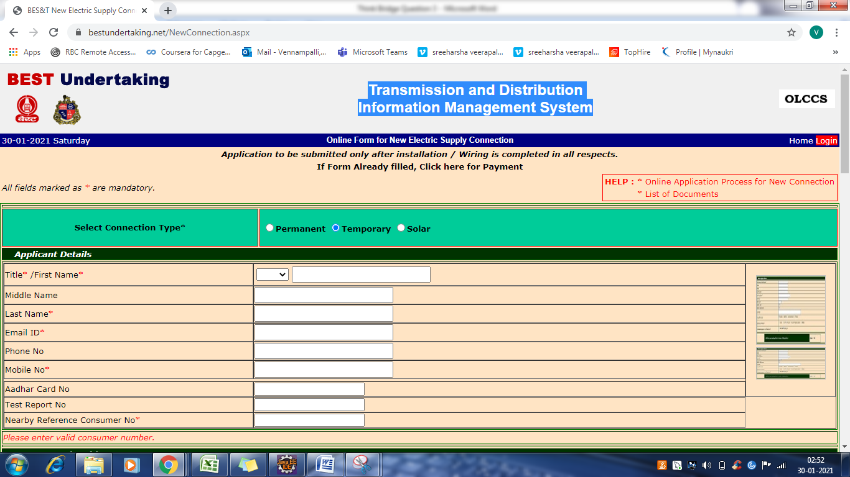

1. **It would look quite better if a single check box is used for I accept by the user instead of radio button of Yes/No and mandate the field to required field**